24th October, 2025

OC Golf Tournament 2025 - Jaypee Greens, Noida
Fairways & Friendships
Event organized by Old Cottonians Association (OCA) Delhi Chapter

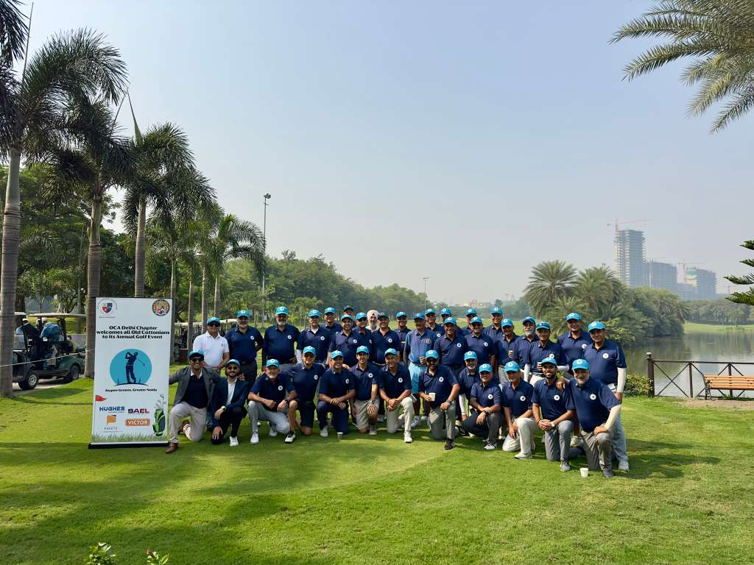
The annual OC Golf Tournament, organized by OCA Delhi Chapter, was less about handicaps and more about handshakes, laughter, and occasional friendly brag. Held under the perfect weather condition and even better spirits, the greens were alive with the sound of old friends reconnecting and competing for a spot in the final 12 to prepare for prestigious Inter-School Golf Tournament to be held later in December - A classic OC way where winning and storytelling goes hand-in-hand.
The morning began with a cheerful chaos - golf bags all over, last-minute coffee runs, and the youngest participant signing in the last to commence the tee off. As the first tee-off began with our beloved 32 golfers, so did the jokes and debates about who still ‘had their swing’. By the fourth hole, it was less about the score and more about the stories - tales from dorm rooms, classroom pranks, and memories that still make us laugh decades later.
Post-game, everyone gathered around for a hearty meal, a few celebratory drinks, and the much awaited prize distribution. Events like this remind us what being an OC truly means - a connection that goes beyond the school walls. The tournament wasn’t just a day of Golf; it was a celebration of friendship, shared history, and that unspoken Cottonian bond that time can’t fade.
Until next time, keep swinging - on and off the course - A true Cottonian affair!

OC Golf Tournament (Participants)
S. No. | Name | Contact | Batch | House
1 | Simran Grewal | 9876300911 | 1998 | Curzon
2 | Madhav Singh | 9810191506 | 1991 | Lefroy
3 | Pranav Roach | 9811024015 | 1980 | Curzon
4 | Arpito Mukerji | 9910299999 | 1985 | Rivaz
5 | Chetan Singh | 9811020062 | 1971 | Ibbetson
6 | Gaurav Misra | 9811228422 | 1984 | Rivaz
7 | Atamjit Singh | 9811042965 | 1974 | Rivaz
8 | Vineet Sarjolta | 9317200395 | 1995 | Ibbetson
9 | Rakesh Puri | 9810011668 | 1976 | Ibbetson
10 | Arun Sirkeck | 9418044545 | 1980 | Ibbetson
11 | Narinder Chauhan | 9418022448 | 1974 | Curzon
12 | Prithvi S Nat | 9650659250 | 1971 | Ibbetson
13 | Prithvi Raj Prem | 8800977488 | 1971 | Rivaz
14 | ⁠Col Malwinder Guron | 9810822488 | 1974 | Curzon
15 | V.M.Sahni | 9810906515 | 1972 | Rivaz
16 | Ashim Kapoor | 9810029492 | 1978 | Lefroy
17 | Cmde AK Aukta | 9874975122 | 1980 | Lefroy
18 | Mohnish Sharma | 9930992094 | 1983 | Rivaz
19 | Ronald Das | 9811020558 | 1974 | Rivaz
20 | Rajan Gupta | 9811054237 | 1968 | Curzon
21 | Sanjeev Sood | 9818020165 | 1978 | Lefroy
22 | Rajeev Sood | 9810033422 | 1979 | Lefroy
23 | Ashok Mathur | 8860278072 | 1971 | Curzon
24 | Col. R. S. Nughaal | 9418081777 | 1982 | Ibbetson
25 | Sanjiv Chadha | 9810124296 | 1974 | Lefroy
26 | Hitesh Chauhan | 9999430004 | 2006 | Ibbetson
27 | Grp. Capt Anil Singha | 9501022216 | 1976 | Rivaz
28 | Rajiv Duggal | 9811160444 | 1979 | Ibbetson
29 | Narinder Yadav | 9810036769 | 1982 | Rivaz
30 | Sanjay Aggarwal | 9810031164 | 1981 | Ibbetson
31 | Amarjeet kukreja | 9810222996 | 1987 | Curzon
32 | Kanishk Sirohi | 9990008066 | 2018 | Curzon

Prizes (Categories)

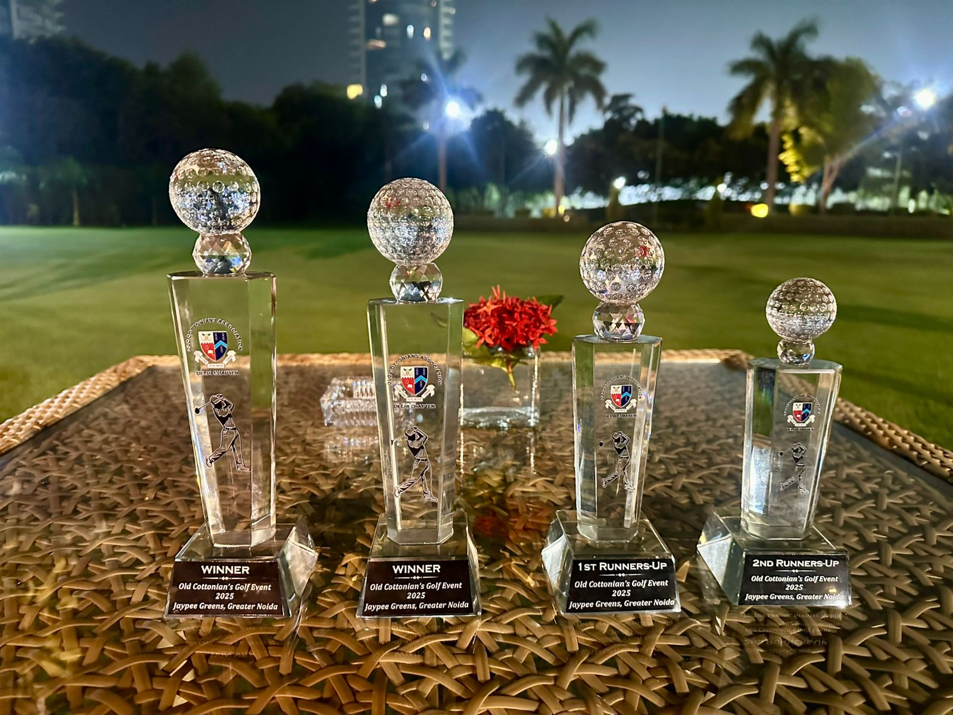
Category | Golfer
Winner - Gross Total | Chetan Singh (‘1971, Ibbetson)
Winner - Net Score | Hitesh Chauhan (‘2006, Ibbetson)
Runner-Up | Ashim Kapoor (‘1978, Lefory)  Simran Grewal (‘1998, Curzon)
2nd Runner-Up | Madhav Singh (‘1991, Lefroy)

Sponsors
A huge thank you to our amazing sponsors!
Hughes Network System India SAEL Industries Limited Victor Tools Facets Fashion

